



[Title]
Value Creation Plan

PE Firm: [Enter PE Firm Name]
Portfolio Company: [Enter Company Name]
Growth Stage: [Early-stage, Growth, Maturity]
Deal Type: [Buyouts, LBOs, Secondaries, Carve-out]
Date: [Enter Date]


Executive Summary

Outline key results from the current state assessment and strategy evaluation, then highlight prioritized initiatives and their expected impact on value creation for the portfolio company.

Purpose | Outline the objective of the assessment (e.g., identify performance gaps).
Key Findings | Summarize the insights from the assessment.
Next Steps | Highlight immediate actions or priorities for further analysis.

Current State Assessment

Business Overview
Metrics |  | Description (Current)
Company Background |  | Brief description of the company’s history, mission, and vision.
Industry Context |  | Overview of the industry and the company’s positioning.
Core Products/Services |  | Summary of key offerings (products or services).
Key Markets |  | Geographic or demographic markets served.
Competitors |  | Key competitors and their market positioning.
[Insert Metric]

Organizational Assessment
Metrics |  | Current State |  |  |  | Comments
Leadership
Workforce
Culture
Capabilities/Skills
Change Readiness
[Insert Metric]

Financial Performance
Metrics |  | Current Value |  |  |  | Benchmark/Target | Comments
Revenue
Profit Margins
Operating Costs
Cash Flow
D/E Ratio
[Insert Metric]

Supply Chain
Metrics |  | Current Value |  |  |  | Benchmark/Target | Comments
Fill Rate
Lead Time
Cash Cycle Time
Order Cycle Time
Gross Margin ROI
[Insert Metric]

Marketing / Sales
Metrics |  | Current Value |  |  |  | Benchmark/Target | Comments
Customer Segments
Net Promoter Score
Mktg Conversion Rate
#SQLs/#MQLs
Sales Conversion Rate
New Clients/#SQLs
[Insert Metric]



Production
Metrics |  | Current Value |  |  |  | Benchmark/Target | Comments
Capacity Utilization
Overall Equipment Effectiveness (OEE)
Production Downtime
Throughput Rate
Machine Uptime Rate
[Insert Metric]

Technology
Metrics |  | Current Value |  |  |  | Benchmark/Target | Comments
System Uptime (%)
Ticket resolution time
Production Downtime
Total Cost of Ownership
IT ROI
[Insert Metric]

ESG
Metrics |  | Evaluation Results
Environmental Impact
(Scope 1, 2, 3)
Social Responsibility
(DEI metrics)
Governance
(Compliance with regulations and ethical standards)

Value Creation Strategy Evaluation

EBITDA Impact: Score (1-10)  Other Metrics:  Score (1-5) | EBITDA Impact | Effort to Implement | Time to Implement | Required  Resources | Risk  Level | Priority  Score
Operational Improvement
Cost Reduction
Supply Chain Enhancement
Strategy Implementation
Business Expansion
Digital Transformation
Pricing
ESG
Organizational Upgrade
Management Structure
Talent Development
Financial Engineering
Capital Structure
Net Working Capital

Value Creation Initiatives

Initiatives | Priority | Description |  |  | KPIs
Smart Manufacturing Integration | High | Deploy IoT and AI to create a smart manufacturing environment. This initiative aims to optimize production processes, reduce downtime, and enhance product quality. |  |  | - 15% increase in Overall Equipment Effectiveness  - 20% decrease in production lead time  - 5% reduction in cost per unit
 | High
 | Medium
 | Medium
 | Medium
 | Low

Value Creation Roadmap

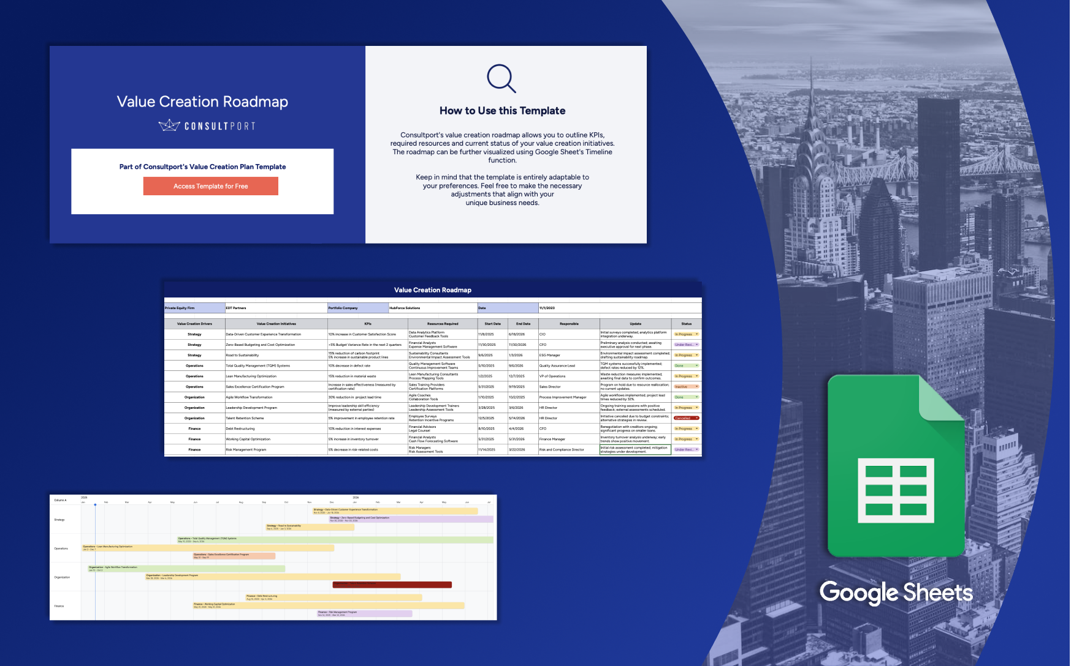


Access Roadmap for Free

